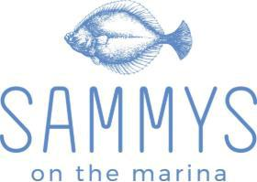

Sammy’s on the Marina Function Room
Holding 150 persons cocktail style or up to 85 persons sit down

The High Tide Room
Our private function room has breathtaking views of
both the beach and the marina.

Holding 80 persons cocktail style or up to 50 persons sit down and with access to its own private bar the High Tide Room is the perfect setting for your next event.

This room is also equipped with AV facilities like projector, screen, mike and speaker.

The Balcony Room

The Balcony Room has breathtaking views of both the beach and the marina. Holding 50 persons cocktail style or 25 persons sit down, the Balcony Room is the

perfect setting for your private events.

Speaker, microphone and exclusive music system can also be provided in this room.

The Open Terrace

The open Terrace has breathtaking views of both the beach and the marina pier. Holding 40 people cocktail style or 30 people sit down, the Open Terrace is the perfect setting for your summer cocktail parties.

The exclusive music system can also be provided in this area.

functions@sammys.net.au

R1/12 Holdfast Promenade, Glenelg

www.sammys.net.au
@sammysonthemarina


Cocktail Function
(Charges Per Person)

Choice of 5 items: $50.00 Per Person

Choice of 7 items: $70.00 Per Person
Free cake cutting

Choice of 10 items: $90.00 Per Person
Free cake cutting + Free welcome drink (Bubbles) on arrival

Choice of 12 items: $100.00 Per Person
Free cake cutting + Free welcome drink (Wines/Beer/soft drinks) on arrival

Vegetarian & Vegan
- Mini Bruschetta Pomodoro tomatoes, basil, garlic, olive oil [Vg option]
- Grilled Vegetable Skewers [GF] [Vg]
- Mushroom Arancini [Vg option]
- Spring rolls [Vg]
- Curry Puff [Vg]
- Crumbed Haloumi
- Assorted Sushi rolls [GF] [Vg option]
- Stuffed Mushroom [GF]
- Eggplant Parmagiana

Hot
- Chicken Satay with Asian Salsa [GF]
- Mini Beef Shashlik with Tzatziki [GF]
- Japanese Panko Prawns with Wasabi Aioli
- Grilled Harvey Bay Scallops with Black Truffle Remoulade [GF]
- Salt & Pepper Squid with Citrus Aioli [GF]
- Fish & Chips with Tartare Sauce
- Steamed or Fried Prawn/Pork/Vegetarian Gyoza with Sesame Soy Sauce
- K I Beef Pies with Homemade Tomato Chutney
- Prawn and Tamarind Noodle Rolls with Sweet Chilli Sauce
- Grilled Prawn Skewers [GF]
- Beef Meatballs and Brava Sauce

Cold
- Coffin Bay Oysters [GF]
- Smoked Salmon with Sour Cream and Chive on Crouton
- Assorted Sushi Rolls and Nigiri with Sesame Soy Sauce [GF]
- Classic Prawn Cocktail with Thousand Island Sauce [GF]
- Sesame Crusted Tuna with Soy and Wasabi Aioli [GF]
- Gazpacho Oysters [GF]

Mini Desserts - $5/Person extra

Cocktail Function
(Charges Per Platter)

Meat Platter @200
Pork Ribs, Gourmet Sausages, Baked Chicken Breast, Australian Wagyu Rump, Chorizo Skewers, Chimichurri, Tomato Chutney, Pitta Bread, Greek Salad

Grazing Platter @ $120
(Minimum 10 platters to order)

Platters are placed down on a grazing table for your guests to help themselves.
Includes-Your choice of any 5 Canapes from the Canapes list. Consist 4 of each item /platter=20items

ADD Extra Sharing platters for 5 pax @$80/platter

Antipasto
Pickled octopus & calamari or Spanish chorizo & salami with camembert and tasty cheese, grilled pita, olives, sundried tomato, grilled eggplant, zucchini and Stuffed bell peppers.

Cheese Platter
Camembert, Tasty cheese, Blue Vein cheese, Mixed Nuts, Crackers & Dried Fruits

Set Menus
(For 15 Guests or above)

Two Course Set Menu $70 Per Person

Choice of 2 Entrée & 2 Mains
or

Choice of 2 Mains & 2 Dessert

Three Course Set Menu $80 Per Person

Choice of 2 Entrée, 2 Mains & a set Dessert

Sapphire Package $90 Per Person (3 courses + Canapés)

3 cold/hot Canapés,
Choice of 3 Entrees, 3 Mains & 2 Dessert

Deluxe Package $100 Per Person (3 courses + Canapes + welcome drinks)

4 cold/hot Canapés + Welcome drinks on Arrival,
Choice of 3 Entrees, 3 Mains & choice of 2 Desserts
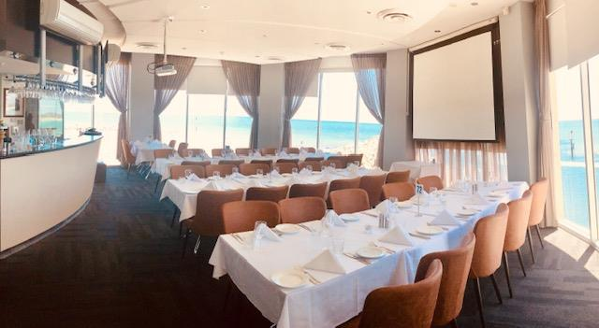

Set Menu
Entrée Choices

Grilled Harvey Bay Scallops
Black Truffle Remoulade / Baby Spinach / Bonito Oil / Fresh Herbs

Ora King Salmon Carpaccio [GF]
Radish / Sweet Peppers Drops / Wakame Vinaigrette / Micro Herbs

Fried SA Squid
Mild Matcha Cajun Spice / Salt Bush / Citrus Aioli

Fried Garlic King Prawns
Beurre Noisette / Confit Garlic / Japanese Panko / Herbs

Grilled Portobello [V] [GF]
Chef’s Hummus / Harissa / Wild Rocket

Pickled Octopus
Taramasalata / Fish Roe / Extra Virgin olive oil

Seafood Chowder
Seafood Medley / Puffed Pastry / Fresh Herbs

Grilled Chicken
Asian Slaw / Teriyaki / Coriander

Main Choices

Australian Wagyu Rump MS 6+ [GF]
Grilled Broccolini / Cured Yolk / Jus Lie

Sous Vide Chicken Breast [GF]
Potato Gratin / English Spinach / Porcini Gel

South Australia Octopus [GF]
Baba Ghanoush / Asparagus Spears / Shallot Crunch / Chimichurri

Baked Ora King Salmon [GF
Sweet Potato Puree / Chickpeas / Dates & Onion Salsa / Fresh Herbs

Balinese Grilled King Prawns [GF]
Fragrance Rice / Balinese Spice / Sambal Matah

Grilled Moreton Bay Bugs
Fermented Garlic & Chili Butter / Rocket & Pear Salad / Lemon Wedges

PASTAS AS MAINS
Marinara Nero
Squid Ink Spaghetti / Prawns / Squid / Salmon / Scallop / Mussels / Cherry Tomato / Chili / Herbs / White Wine and Extra virgin Olive Oil Emulsion

Gnocchi di Verdure
Pan Fried Pumpkin Gnocchi / Broccolini / Roasted Capsicum / Onion / Gorgonzola Dolce

Exclusive Choices only for Deluxe Package
Antipasto (Entrée cold dish)
Pickled octopus & calamari or Spanish chorizo & salami with camembert and tasty cheese, grilled pita, olives, sundried tomato, grilled eggplant, zucchini and bell peppers.

Eye Fillet surf (Main course)
Served with seasonal vegetables, prawns, garlic white wine cream.

Dessert Choices

Salted Caramel Cheesecake
Served with toffee and caramel sauce

Vanilla Bean Panna Cotta
With Berries Compote, Persian Fairy Floss and Strawberry dust

Chocolate Lava Cake
Raspberry Crunch and White Chocolate Crumbs

Trio of Sorbet Ice Cream [GF] [Vg]
Three sorts of sorbet served with fresh fruit.

ADD Extra Sharing platters for 5 pax @$80/platter
- Antipasto
Pickled octopus & calamari or Spanish chorizo & salami with camembert and tasty cheese, grilled pita, olives, sundried tomato, grilled eggplant, zucchini and bell peppers.

-Cheese Platter
Camembert, Tasty cheese, Blue Vein cheese, Nuts, water Crackers & Dry Fruits

Please let us know about your dietary requirements!

‘’Menus are flexible. If you don’t see your dish here, please let us know and our chef will be happy to try to

create something for you.’’
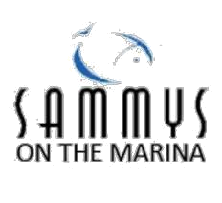

Drink Packages

Includes
Beer/Cider

Peroni, Corona, Asahi, Hahn light, James Boags, Kronenburg 1664, Apple Cider, Pear Cider.

(Please Select any 4 from above)

Wine

Sparkling – Serafino

White Moscato/Sauvignon Blanc – Serafino
Red – Shiraz - Serafino
Unlimited - Soft Drinks/Juices

- Hours $40.00 Per Person
- Hours $50.00 Per Person
- Hours $60.00 Per Person

BAR TAB: You may choose to run an on-consumption bar tab for your group, rather than price per person packages.
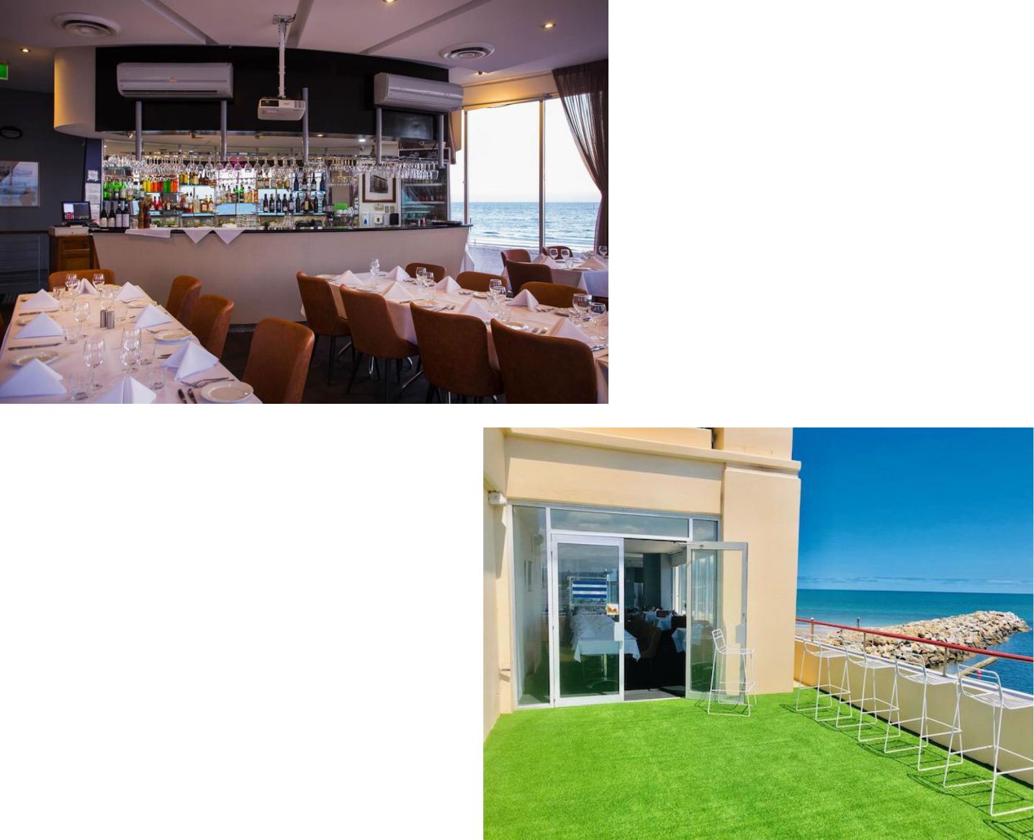
TERMS & CONDITIONS

July 2020
Commencement and vacating of rooms

The Client agrees to begin the function and vacate the designated function space at the time agreed upon on the Banquet Event Order. In the event that a function should go beyond the agreed finish time, the Centre reserves the right to charge whatever extra costs are reasonably incurred.

Surcharges

A surcharge will apply for those functions that continue after midnight until 1.00am. Gazette Public Holiday functions will attract a surcharge of 15% on food and beverage.

Please note that Public Holiday surcharges apply at 20%, of the total Food and Beverage Revenue.

Bookings/Deposit (Non-Refundable)

Corkage
There will be a surcharge for corkage of $15/bottle.

Celebration Cakes

There is a surcharge of $15.00, Sammy’s will supply the cutting knife and plates for client to cut cake with. Celebration cakes must be assembled by the client or a designated person on their behalf.

If the cake is required to be cut, this can only be done by Sammy’s staff at an additional price of $5 per plate.

There is a fee of $7.50 per plate for the cake to be cut by the kitchen, plated and garnished.

Please be aware that bookings are not confirmed until a $10/person deposit has_{TERMS & CONDITIONS} been received AND Banquet Event Order has been signed and returned; the

deposit is then subtracted from your bill at the completion of your event. Deposits _{Decorations} can be paid by credit card, EFT or cash. Please note if a deposit is paid via EFT
Sammy’s on the Marina requires a receipt. | You are welcome to decorate the room yourself during regular opening hours
Sammy’s on the Marina requires a receipt. | only. Only Blu-Tac may be used to affix posters, streamers, etc. to walls. If you
Payment | wish to use glitter or scatters (or similar), a cleaning fee will apply. Naked flames
Full payment is to be made 3-7 days prior to your function date. Methods of and sparklers are NOT permitted (birthday candles are allowed, but only in the payment include most major credit cards, EFT or cash. Any extras that are allocated cake position within each room).

required on the day of the function must be paid at the conclusion of the function, prior to client departing.

Cancellations

In the event that a function is cancelled, the following conditions shall apply:

A- within 6 months of the function date, all deposits shall be forfeited unless the room is resold

Special Effects

Smoke machines, dry ice machines and pyrotechnics are not permitted. No wax candles are permitted within Sammy’s without prior written approval from the Events Coordinator. Where a Fire Warden is required to attend the venue because of the number of candles, a charge to the client will apply.

Confetti Substances

No confetti or confetti substances are permitted anywhere in Sammy’s including
B- within 90 days of the function date, all deposits shall be forfeited, and the the grounds. If any of these substances are found after an event the client will be
Client shall pay a fee of up to 50% of the estimated cost of said function | charged a cleaning fee to cover the cost of removing these substances
C- within 30 days of the function date, all deposits shall be forfeited, and the ^{Food Safety and Hygiene}
Client shall pay a fee up to 75% of the estimated cost of said function | Please be advised that Sammy’s on the Marina abide by all local standards on food
and beverage safety and hygiene. Kitchen personnel are trained in proper
D- within 7 days of the function date, all deposits shall be forfeited, and the Client temperature, handling of food, and cleanliness of food preparation areas.
shall pay a fee up to 100% of the estimated cost of the said function.
Smoking / Fire Alarms
Smoking throughout the venue is prohibited. There are designated areas on the
Final Numbers
marina for smoking.
Please confirm final minimum numbers 30 days prior to your function to allow for

correct catering and staffing purposes. Reduction in Guest Numbers in the event Responsibility

that within 60 days of the function, the expected attendance figure is reduced by Organizers are financially responsible for any damage or breakage sustained to the more than 20%, the Client will be liable to pay for up to 50% of the resultant restaurant or equipment hired by Sammy’s on the organizer’s behalf, by the reduction in function cost (based only on the reduction in excess of 20% - Does organizer or any of their guests. Sammys will not accept any responsibility for loss
not apply where minimum numbers are required). | or damage to personal effects left within the during or after the function.

Re-Allocation of Rooms

Sammy’s reserve the right to re-allocate function rooms due to circumstances beyond our control. If the final numbers increase or decrease significantly from those advised at the time of reservation, we may substitute a more appropriate room of our choice. Any changes will be discussed with you at the appropriate time.

Room Rates

Room rates include room hire, clothed tables and water on tables. Including the use of audio visual (overhead projector and screen), pens and pads of paper.

Menu Selection and Beverages

Food and beverage selections to be confirmed no later than 30 days prior to your function. This includes dietary requirements (i.e. vegetarian, gluten free, etc.). No outside catering can be brought onto the property (with the exception of a celebration cake).

Band meals

The Musician’s Award stipulates that all entertainers must be provided with a meal. These are provided at a nominal charge to the Client.

Noise & Alcohol Consumption Outside

From 12am midnight no patron is to be outside on the balcony area and the door will be closed. After this time, staff can request that patrons are not to use the balcony area for drinking.

Subject to Change

Price, menu, room allocations and terms and conditions are subject to change without notice.

Security

Arrangement for security can be made on request for an additional fee. All functions over 100 require security.

Cleaning

General and normal cleaning is included in room hire charges. Additional charges may be incurred by you in instances where an event has created cleaning requirements which are over and above normal clean.

