Beer
IN THE TAPS Shmiddy Schooner Pint
355ml 425ml 570ml
Brick Lane ‘One Love’ 4.4% $7 $9 $11
Slipstream Billy Cart 3.5% $7 $9 $11
CANS & BOTTLES
Red Hill Brewery Scotch Ale
Mornington Peninsula 5.8% $10
Stone & Wood Pacific Ale
Byron Bay 4.4% $7.5
XXXX Gold Lager
Brisbane 3.5% $5
Asahi ‘Super Dry’ Lager
China 5% $8
Revel Indian Pale Ale
Brisbane 7.5% $9
Brouhaha Strawberry & Rhubarb Sour
Maleny 4.2% $8.5
Golden Bone Brown Lager
Gypsy 4.8% $9
Willy Smiths Organic Apple Cider 5.4% $11
Tasmania

Cocktails
Baileys Affogato
Ice cream, flywheel, baileys in a short glass $10
Mimosa
Prosecco, Hrvst St OJ, Campari $10
Aperol Spritz
Petes Pure Prosecco, Aperol, soda, orange $13
Steamtrain Espresso Martini
Flywheel, Vodka, syrup $16
Negroni
Tanquerey Gin, Dolin Vermouth, Campari $16
Old Fashioned
Makers Mark, bitters, brown sugar, orange $16
Cuban Mojito
Fresh mint & lime, Sailor Jerry, soda & crushed ice $16
Sour
Bourbon, Whiskey or Rum
Lemon juice, egg white, sugar $18
Classic Margarita
Tequila, Cointreau, lime $18
Mojito Elegante
Tequila añejo, Proseccco, lime, mint $17
Himalayan Hot Binder
Vodka, Gin, Vermouth, egg white, lemon Jalapeño $18

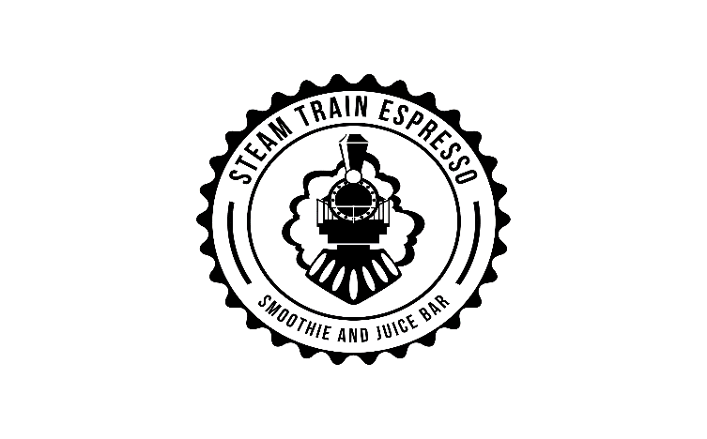

Spirits
Rum
Sailor Jerry USA $9
Rebellion Bay Trinidad & Tobago $10
Havana Club Añejo 7 Años Cuba $11
Gin
Tanquerey England $11
Poor Toms Australia $13
Vodka
Russian Standard Russia $8
Absolut Sweden $9
Bourbon/Whiskey
Wild Turkey USA $10
Makers Mark USA $10
Glen Grant 12yo Scotland $12

NON-ALCOHOLIC
Table water
Still no charge
Sparkling water (700ml) $3
Smoothies
Your choice of milk/mylk/coconut water 400ml
Banana – banana, cinnamon, raw honey $8
Banana berry – banana, strawberries, blueberries, raw honey $8
Banana mango – banana, mango, raw honey $8
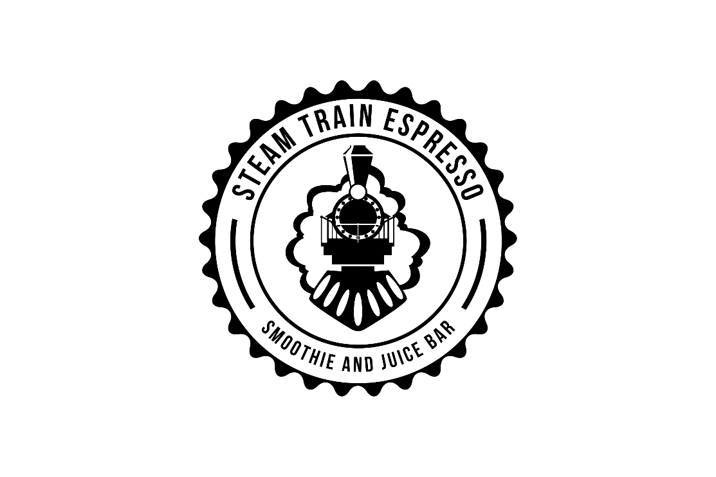
Green – spinach, banana, apple, pear, dates $9
Big Breaky - banana, blueberries, peanut butter,
oats, dates $9
Cold Pressed Juice by HRVST St
400ml
Orange $7
Watermelon Apple Pear & Lime $7
Lemon Pine Cayenne Green Apple $7
Kale Cucumber Lemon Spinach Pear $7
Fruit Crush 400ml
Frozen fruit blended with ice & apple juice
Pine lime $7
Apple & berry $7
Strawberry & Pineapple $7
Mango $7

Wine
Sparkling
Pete’s Pure Prosecco, Wentworth NSW $9/38
Crisp apple & apricot, light, dry & uncomplicated, easy drinking, crowd pleasing, sessionable.
Harvest, Northern Adelaide Hills Bottle $49
Refreshingly dry sparkling chardonnay with a crisp clean finish.
Pretty Boy Rosato, Delinquente wine co. $12/$45
Riverland SA
Freeze dried strawberries in a bottle, deliciously moreish.
White
Pete’s Pure Pinot Grigio Euston, NSW $9/$38
Honeysuckle, ripe melon & almonds, fresh and delicious
Pete’s Pure Sauv Blanc Pemberton, WA $9/$38
Lychee & Passionfruit, simple, uncomplicated & enjoyable.
Poggio Anima ‘Gabriel’ Pecorino, Italy $13/$46
Apricot, lemongrass, golden delicious apples, savoury yet fruity, complex and extremely enjoyable.
Snake & Herring ‘Tough Love’ Chardonnay $16/$52
Margaret River WA
Clean, crisp, dry Chardonnay, light on citrus & melon acidty.
Red
Pete’s Pure Pinot Noir $9/$38
Wentworth, NSW
Ripe cherries, with a hint of vanilla bean, simple & smooth
Pete’s Pure Shiraz Euston, NSW $9/38
Uncomplicated, clean and easy drinking with notes of blackberry & oak & light spice.
Dormilona Shiraz Margaret River, WA $12/45
Easy drinking and smooth with flavours of dried mulberries & blueberries. Minimal intervention processes & organic grapes make this something special for those who like medium body & plenty of flavour & low tannin.
Sons of Eden ‘Marschall’ Shiraz, $15/$54
Barossa Valley
Fresh, juicy dark berries with a distinct savoury edge
Pepik Pinot Noir 2017 Tasmania $15/$49
Josef Chromy, ripe cherries and blackberries, bright raspberry acidity, complex & delicious.

